1. What is Boolean? Write down 3 different expression that results a Boolean type.
   * Boolean được gọi là kiểu “luận lý” hay là kiểu “đúng sai” vì nó chỉ chứa 2 giá trị là đúng (True) và sai (False)
   * Ví dụ về kiểu Boolean :

>>> 10 == (7 + 3)

True

>>> 6 == 9

False

>>>name = "Huyen"

>>> name + "Xinh" == "HuyenXinh"

True

1. What is a flow chart? Draw flow chart for the following code snippet:
   * Flow chart dùng để biểu diễn thuận toán. Nó mô tả quá trình nhập, xuất dữ liệu và quá trình xử lý thông tin

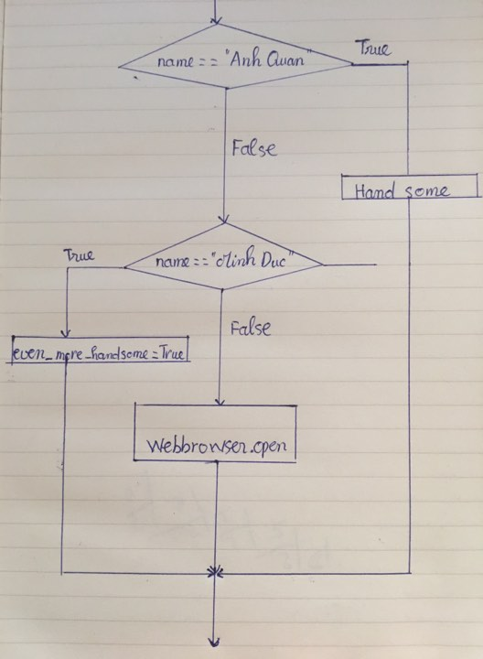

1. What is nested conditionals? Write a piece of code that uses nested conditionals
   * Nested conditionals là bên trong mỗi điều kiện có một điều kiện khác nữa
   * Ví Dụ :

**if x < 0:**

**print("The negative number ", x, " is not valid here.")**

**else:**

**if x > 0:**

**print(x, " is a positive number")**

**else:**

**print(x," is 0")**